DATE: 16.08.2019
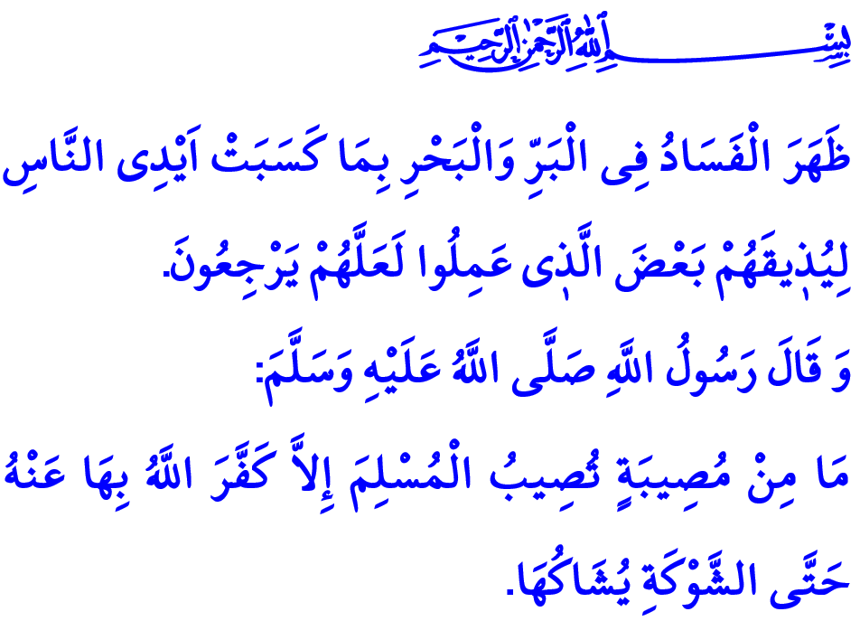
PREPAREDNESS AGAINST DISASTERS FOR A SAFE AND SECURE LIFE
Honorable Muslims!
In the verse I have just recited the Almighty Allah (swt) states, “Corruption has appeared throughout the land and sea by [reason of] what the hands of people have earned so He may let them taste part of [the consequence of] what they have done that perhaps they will return [to righteousness].”
In the hadith I have just read the Prophet Muhammad (saw) says, "Even if it were the prick he receives from a thorn, but that Allah expiates some of his sins for that."
Dear Believers!
We have come from Allah (swt) and to Him we will return. We are conscious of the fact that Allah (swt) puts all of us to a variety of tests in this world. We wholeheartedly believe that the life in this world is temporary and that in the Hereafter is eternal. We display gratitude to Allah (swt) for the blessings, and patience and resoluteness for the troubles. In Him we trust and on Him we rely. However, we as human beings still keep trying to fulfil our responsibilities against natural disasters.
Honorable Muslims!
Allah (swt) has created the entire nature as a whole, from the largest galaxies to the tiniest little ants, and oversees everything at all times. On His ruling and laws depend the hilarious harmony and balance of the nature.
Sometimes it is not only the nature that is upset by some disasters, but also the lives of people, in a bitter way. Throughout the history disasters such as earthquakes, floods, landslides, and fires have resulted in many losses of life and property. The pain caused by the earthquakes and floods in the near past of our country is still fresh in our hearts.

Dear Believers!
Allah (swt) commands people, “And cause not corruption upon the earth after its reformation.” By people who irresponsibly waste the nature, cut the trees in forests for personal benefits, pollute the air and water, desertify the earth is disturbed the balance on Earth. The majority of the bitter results of disasters are due mostly to our own mistakes and neglects. In this regard states the Almighty Allah (swt), “And whatever strikes you of disaster - it is for what your hands have earned; but He pardons much.”
Dear Muslims!
Muslims have absolute faith that what Allah (swt) has preordained will eventually take place. They are aware, however, that the natural phenomena take place in accordance with the divine order and laws on a cause and effect basis. They do not simply rely on the fact that "What Allah (swt) wills happens." by ignoring the importance of exerting efforts and seeking opportunities for desired results. They watch their steps in terms of harmfulness to the nature and avoid acts that invite disasters. They show due diligence in their works, and take necessary measures. Only after deploying material and non-material means and fulfilling their responsibilities do they wait for Allah's (swt) decision. As the Prophet Muhammad (saw) expresses, “They first tie their camels and then place their trust in Allah.”
Dear Believers!
Let us take necessary measures for a secure life. Let us be conscious of and prepared for disasters. Let us take into consideration the location for constructing residential places in terms of risk of earthquake, landslides, and floods. Let us inform our family members on disasters and emergencies. Let us apply to provincial directorates of the Disasters and Emergency Management Presidency of Turkey, for first aid training, information and support.
May Allah's (swt) mercy be upon our fellow citizens who have lost their lives in disasters occurring in our country, and particularly upon those who have lost their lives in the 1999 Marmara Earthquake, the 20th anniversary of which we will commemorate tomorrow. May the Almighty Allah (swt) protect us, our nation, and Muslim world against all kinds of disasters. May He also allow us to take necessary lessons from the past disasters, to fulfill our responsibilities, and lead a peaceful and secure life.

Rum, 30/41.
Bukhari, Marda, 1.
A’raf, 7/56.
Shuraa, 42/30.
Tirmidhi, Sifat al-Qiyamah, 60. General Directorate of Religious Services

